1. <ng-template>: This is built-in Component (directive) shipping with Angular package which can be used to mark places in DOM. 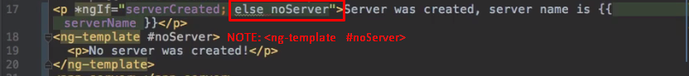
2. 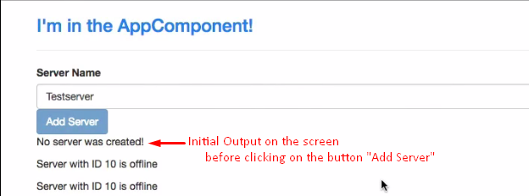
3. 